Lesson learnt:

Predictive analytics don produce prefect prediction and they are no the best techniques :

It’s important to remember that even the best models are subject to significant misclassification. Illustrated below is an example of a model that is designed to predict the number of “green dots” in a box. As demonstrated, it shows misclassification where “red dots” as well as “green dots” are incorrectly predicted and classified.

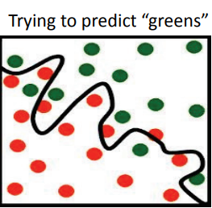

2- Predictive Models are not foolproof, ie. Good software tools don’t implie good models.

There is often a false sense of security that comes with using a good software tool. In our experience, building a good model is not a “press the button” solution. There are several key tasks to perform: • Data specification and pull • Data cleaning and preparation • Variable transformation and selection • Model training and validation • Choosing the best model based on business context In addition, there is a need to recruit team members with the appropriate skills and experience to execute a successful modeling project. As a side, if one is considering developing their PA skills, we would suggest intensive hands on training of the following commonly used techniques as well as soliciting mentors to help develop models.